THE PRESIDENT’S OFFICE
REGIONAL ADMINISTRATION AND LOCAL GOVERNMENT
FORM TWO JOINT EXAMINATION FOR GOVERNMENT SCHOOLS –JEGOS


PRE-MOCK EXAMINATION
012 HISTORY
MARKING SCHEME 2024

SECTION “A” 15 MARKS

D | A | B | B | A | C | D | B | B | C
1O marks

E | G | B | H | I
5 Marks.

SECTION “B” 70 MARKS
- Short notes questions 2(5) = 10
- cow-horn formation was a Ngoni Military technique that involved encircling the enemies before attacking them.
- Feudalism, was the third and the second pre-capitalist exploitative mode of production. It was featured by existence of two classes, the class of landlords and the tenants. In East Africa, it had many forms such as Ubugabire, Unyarubanja, Umwinyi and the like.
- Pombeiros, was a group of a class of Half-cast who helped the Portuguese to get slaves in the coast of Angola and Mozambique
- Missionaries, was a group of Europeans who came to Africa primarily to spread Christianity. They also played a very important role in the abolition of slave trade in the interior of Africa.
- Kaffir wars, was a series of conflicts between the Dutch and the natives namely the Xhosa of Eastern Cape province. The Kaffirs took place from 1779 to 1803. These wars caused insecurity, loss of human lives, the destruction of property and displacement of natives especially the Xhosa who were forced to quit their natives areas.

1st | 2nd | 3rd | 4th | 5th
III | II | V | I | IV

- Short notes questions 2(5) = 10
- The search for an alternative sea route to India was mainly contributed by the Ottoman Empire that blocked the land route and hence there was a need to find an alternative sea route to India.
- Was due to the fact that their areas received a minimum amount of rainfall that did not support crop cultivation but few pastures for animal husbandry hence the reason as to why they engaged in pastoralism.
- The people who lived along lake Nyassa in present day Malawi were the Mang’anja. The Mang’anja utilized their natural environment by burning salty reeds to get ashes, the ashes were then sieved to obtain a solution that was later boiled and evaporated to get salt crystals.
- The Swahili and Arabs along the coast of East Africa fought against the Portuguese because they wanted to regain their lost social, political and economic interests.
- Industrial revolution replaced human labour due to the use of machines in production but on the other hand European manufacturers needed raw-materials and market from Africa which would not be gotten if slave trade was still going on, hence the abolition for the abolition.

- Short notes responses. 2(5) = 10
- Ngoni migration was the movement of the Ngoni from Natal, South Africa to Central and East Africa whereas Boer trek was the movement of the Dutch from the Cape northwards to the interior of South Africa.
- Ubugabire was a feudal system that was dominant among the Ha, Tutsi and Hutu in Rwanda, Burundi and Buha. This feudal system based on cattle and land ownership whereas Unyarubanja was a feudal system that was dominant in Buhaya and Karagwe, it based only on land ownership.

- Nomadic pastoralism was a type of pastoralism where by the keepers moved from one place to another searching for water and pasture. Examples of nomadic pastoralists are such as the Maasai, the Karamajong, Teso, Fulani, Hausa to name a few on the other hand sedentary pastoralism, is another type of pastoralism in which keepers did not move from place to place. They settled in one areas for so long.
- Trans-Saharan trade was the exchange of goods between West Africa and North Africa across the Saharan desert. It lasted for a period of eight centuries that is from 8th century to 16th century. It contributed much to the growth of Western Sudanic states. WHILE Triangular slave trade was an intercontinental trade that involved three continents, Europe, Americas and Africa. It took place from 15th century to 18th century. It contributed to the rise of Forest States of West Africa.
- Centralized political system referred to the pre-colonial political organization with a central figure of authority. The centralized political system or states in pre-colonial Africa were headed by Kings, Queens or Emperors and a good example of those states were such as Ghana, Mali, Luba and the like. But Decentralized political system referred to the political organization without a central figure of authority. In decentralized systems, the states were ruled by either the Council of elders or clan heads.

- 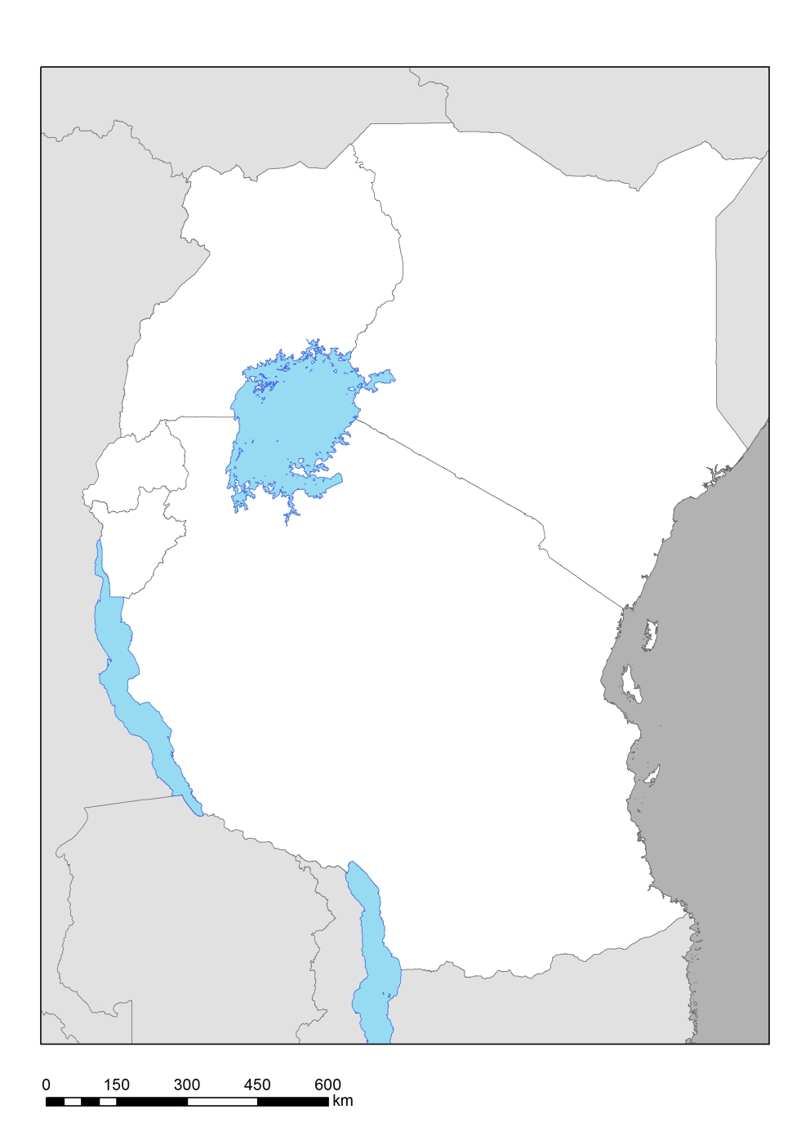
III
IV
V
I
II

2(5) = 10
- Factors that facilitated Early contact between the people of East Africa and those from Middle and Far East.
- The increased dependency of the East African trading centres on foreign trade.
- Availability of trade goods such as ivory, gold, animal skin, slaves, mangrove poles and the like.
- The availability of monsoon winds 2(5) = 10
- The development of marine technology
- Accessibility of the coastal areas of Africa made it easy for traders and travelers to access both ends.

- With the aid of relevant examples explain how did the missionaries contribute to the colonization of Africa.
- They built schools, hospitals and churches.
- They preached the word of God and converted some Africans to Christianity
- They encouraged development of agriculture and research on some cash crops
- They formed trading companies for buying cash crops from Africans and selling manufactured goods to them.
- They campaigned for the abolition of slave trade.

- Essay question.

Introduction
- Definition
- Participants 2 Marks
- Periodization
Main body
Ways used to abolish slavery and slave trade.
- The Berlin Act (article 35)
- Signing treaties
- Intellectual writings
- Anti-slavery campaigns 2(6) =12 marks
- The use anti-slavery patrol naval ships
- The use of African informers
Conclusion
Any relevant conclusion. 1 mark.

